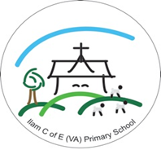

Ilam C of E (VA) Primary School
“Learning, achieving and thriving as a school family through God’s love.”
“For I know the plans I have for you,” declares the Lord, “plans to prosper you and not to harm you, plans to give you hope and a future.” (Jeremiah 29 v11)

3 Year Rolling PSHE Overview - Squirrel Class (Year 1, 2, 3)
 | Autumn 1 | Autumn 2 | Spring 1 | Spring 2 | Summer 1 | Summer 2
Year A | Aiming High  (KS1) | Safety First  (KS1) | Digital Wellbeing  (KS1) | TEAM  (KS1) | Think Positive  (KS1) | Diverse Britain  (KS1)
Year B | VIPs  (KS1) | Be Yourself  (KS1) | It’s My Body  (KS1) | One World  (KS1) | Money Matters  (KS1) | Growing Up  (KS1)
Year C | Aiming High  (LKS2) | Safety First  (LKS2) | Digital Wellbeing  (LKS2) | TEAM  (LKS2) | Think Positive  (LKS2) | Diverse Britain  (LKS2)

Online Safety to be taught throughout the year when appropriate.

