Year 1 Overview : Maths : 2020/21 : Squirrel Class
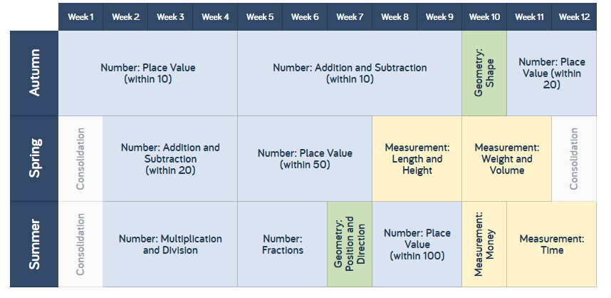

Each week the children will follow the White Rose Maths scheme. They will also have extra sessions focussing upon basic skills relating to number to ensure any gaps of learning are plugged due to the Covid19 crisis of 2020.

Year 2 Overview : Maths : 2020/21 : Squirrel Class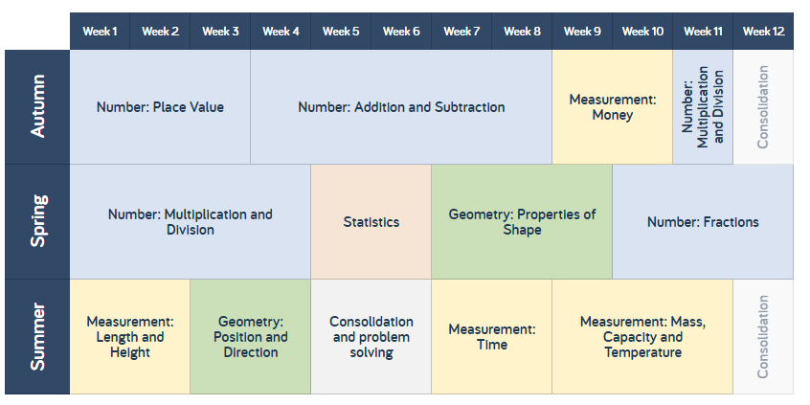 Each week the children will follow the White Rose Maths scheme. They will also have extra sessions focussing upon basic skills relating to number to ensure any gaps of learning are plugged due to the Covid19 crisis of 2020.
Year 3 Overview : Maths : 2020/21 : Squirrel Class 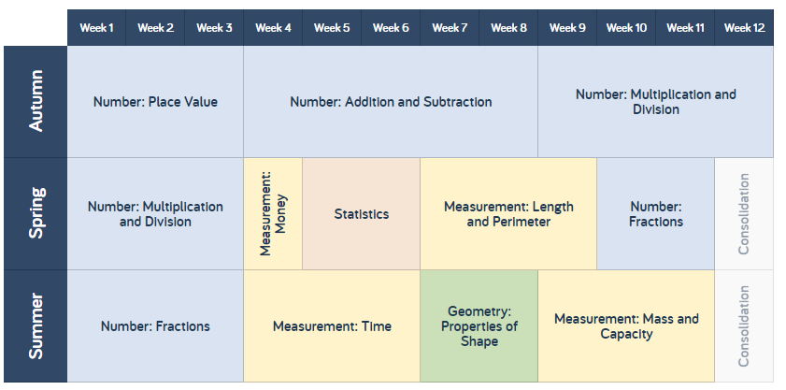 Each week the children will follow the White Rose Maths scheme. They will also have extra sessions focussing upon basic skills relating to number to ensure any gaps of learning are plugged due to the Covid19 crisis of 2020.

